Hong Kong Exchanges and Clearing Limited and The Stock Exchange of Hong Kong Limited take no responsibility for the contents of this announcement, make no representation as to its accuracy or completeness and expressly disclaim any liability whatsoever for any loss howsoever arising from or in reliance upon the whole or any part of the contents of this announcement.
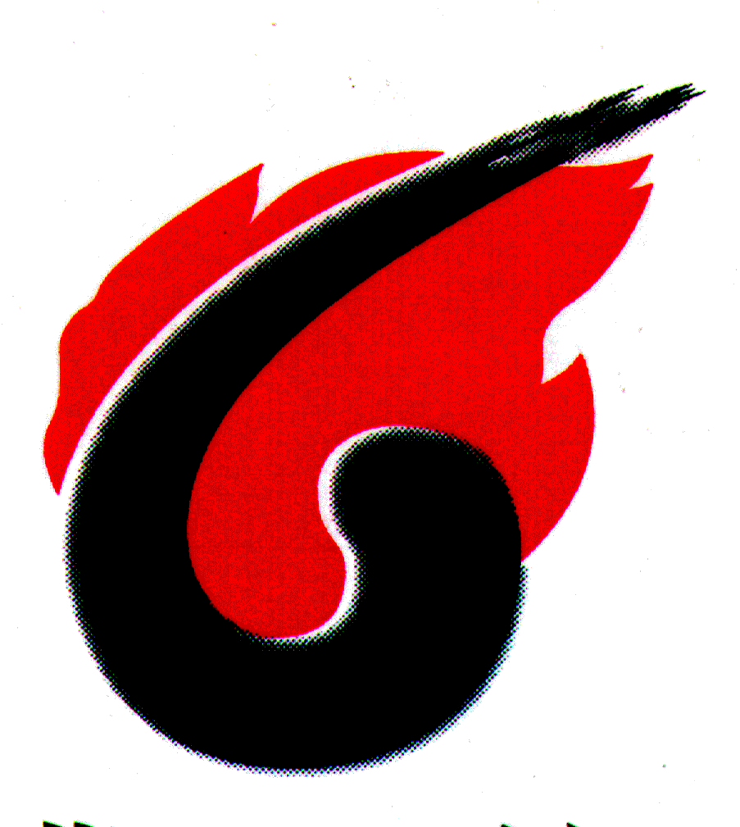
兗州煤業股份有限公司
YANZHOU COAL MINING COMPANY LIMITED
(A joint stock limited company incorporated in the People’s Republic of China with limited liability)

(Stock Code: 1171)

PUBLICATION OF THE PRODUCTION AND SALES VOLUME FOR THE THIRD QUARTER OF 2017 OF AN OVERSEAS SUBSIDIARY CONTROLLED BY YANZHOU COAL MINING COMPANY LIMITED

This is a voluntary announcement made by Yanzhou Coal Mining Company Limited (the “Company”).

Yancoal Australia Limited (“Yancoal Australia”) (a subsidiary controlled by the Company), the shares of which are listed on the Australian Securities Exchange (the “ASX”) (stock code: YAL), published its coal production and sales volume for the third quarter of 2017. The major details are set out below:

 |  | For the third quarter  of the year |  |  | For the first three quarters  of the year
 |  | 2017 | 2016 | increase/  decrease | 2017 | 2016 | increase/  decrease
Saleable coal production (Unit: kiloton) | total | 8,216 | 5,432 | 51% | 18,958 | 14,287 | 33%
Saleable coal production (Unit: kiloton) | equity interest | 6,086 | 4,423 | 38% | 14,793 | 11,479 | 29%
Sales volume of saleable coal  (Unit: kiloton) | equity interest | 7,153 | 5,160 | 39% | 17,230 | 13,126 | 31%

Please refer to the full report published by Yancoal Australia at the website of the ASX (http://www.asx.com.au/asx/statistics) for further details.

By order of the Board
Yanzhou Coal Mining Company Limited
Li Xiyong
Chairman of the Board

Zoucheng, Shandong Province, the PRC
20 October 2017

As at the date of this announcement, the Directors of the Company are Mr. Li Xiyong, Mr. Li Wei, Mr. Wu Xiangqian, Mr. Wu Yuxiang, Mr. Guo Dechun, Mr. Zhao Qingchun and Mr. Guo Jun, and the independent nonexecutive Directors of the Company are Mr. Kong Xiangguo, Mr. Jia Shaohua, Mr. Poon Chiu Kwok and Mr. Qi Anbang.

